Antipodal Nature
# Source: AI Source: Provided by: [Data Path: Persons Table -> ID Column: 1, Name_En Column: Motasem Essam] -> From: [ChatGPT] on [7/25/2026]
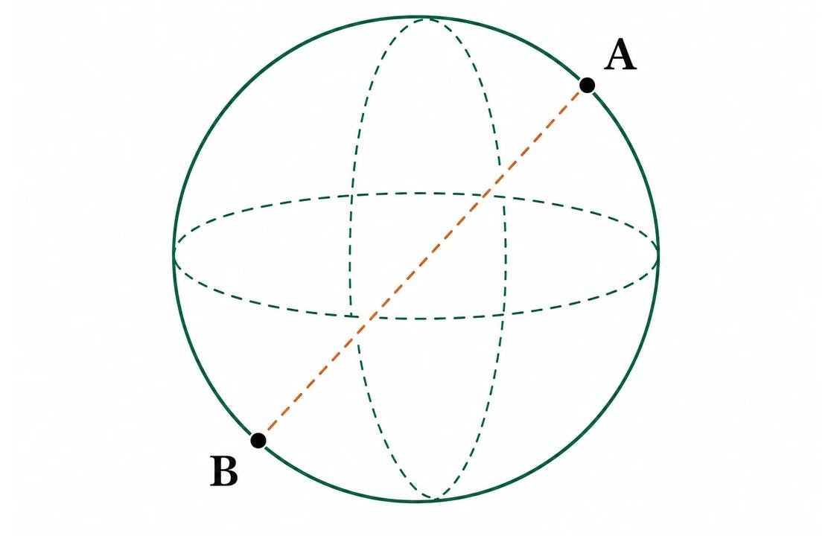
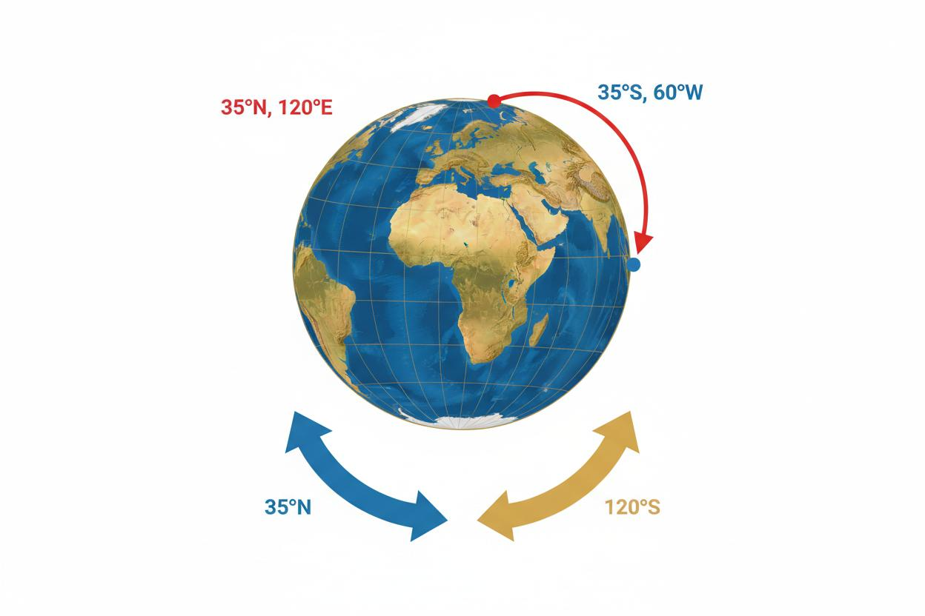
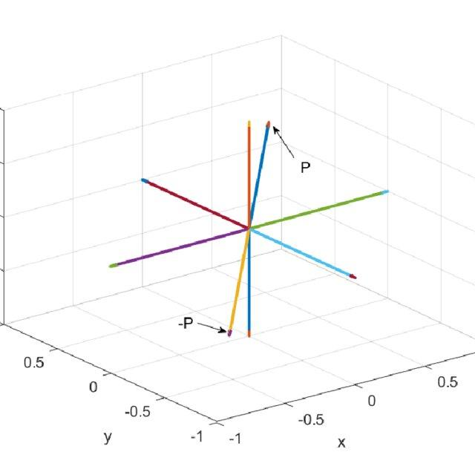

Definition
# Source: AI Source: Provided by: [Data Path: Persons Table -> ID Column: 1, Name_En Column: Motasem Essam] -> From: [ChatGPT] on [7/25/2026]
The antipodal nature of a sphere is the property that every point on a sphere's surface has a corresponding antipodal point directly opposite it, such that the two points and the sphere's center lie on the same straight line.
The line segment joining two antipodal points is a diameter of the sphere, and the center is the midpoint of that diameter.

Simple Definition
# Source: AI Source: Provided by: [Data Path: Persons Table -> ID Column: 1, Name_En Column: Motasem Essam] -> From: [ChatGPT] on [7/25/2026]
Two points on a sphere are antipodal when they lie on opposite ends of a diameter, directly across the sphere from each other.
For example, the North Pole and South Pole are antipodal points on Earth when considered relative to Earth's center and polar axis.

Geometric Representation
# Source: AI Source: Provided by: [Data Path: Persons Table -> ID Column: 1, Name_En Column: Motasem Essam] -> From: [ChatGPT] on [7/25/2026]
The diagram illustrates three essential elements:
- Point $A$: A point on the sphere's surface.
- Point $B$: The antipodal point directly opposite $A$.
- Center $O$: The midpoint of the diameter $AB$.
The relationship can be written as:
$$A, O, B\text{ are collinear}$$
$$OA=OB=R$$
$$AB=2R$$
where $R$ is the sphere's radius.

Mathematical Properties of Antipodal Points

Equal Distance from the Center
# Source: AI Source: Provided by: [Data Path: Persons Table -> ID Column: 1, Name_En Column: Motasem Essam] -> From: [ChatGPT] on [7/25/2026]
Both antipodal points lie on the sphere's surface, so each is one radius away from the center:
$$\boxed{OA=OB=R}$$

Diameter Relationship
# Source: AI Source: Provided by: [Data Path: Persons Table -> ID Column: 1, Name_En Column: Motasem Essam] -> From: [ChatGPT] on [7/25/2026]
The straight-line distance between antipodal points is the sphere's diameter:
$$\boxed{AB=2R}$$

Midpoint Property
# Source: AI Source: Provided by: [Data Path: Persons Table -> ID Column: 1, Name_En Column: Motasem Essam] -> From: [ChatGPT] on [7/25/2026]
The sphere's center is the midpoint of the segment joining the two antipodal points.
$$\boxed{O=\frac{A+B}{2}}$$
This midpoint formula assumes that $A$, $B$, and $O$ are represented by their position vectors or coordinates in the same Cartesian coordinate system.

Vector Representation
# Source: AI Source: Provided by: [Data Path: Persons Table -> ID Column: 1, Name_En Column: Motasem Essam] -> From: [ChatGPT] on [7/25/2026]
If the sphere is centered at the origin and a point has position vector
$$a=\left(x,y,z\right),$$
then its antipodal point has position vector
$$\boxed{b=\left(-x,-y,-z\right)}$$
Both points have the same distance from the origin but lie in opposite directions.

Examples of Antipodal Pairs

General Antipodal Points
# Source: AI Source: Provided by: [Data Path: Persons Table -> ID Column: 1, Name_En Column: Motasem Essam] -> From: [ChatGPT] on [7/25/2026]
Any point on a sphere and the point directly opposite it along a diameter form an antipodal pair.
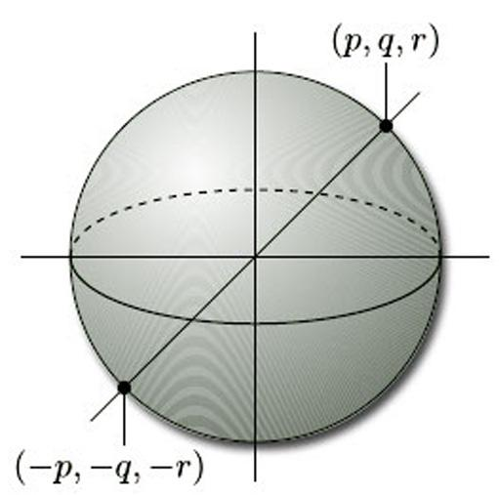

Polar Antipodal Points
# Source: AI Source: Provided by: [Data Path: Persons Table -> ID Column: 1, Name_En Column: Motasem Essam] -> From: [ChatGPT] on [7/25/2026]
The North Pole and South Pole are antipodal points in the idealized spherical model of Earth.
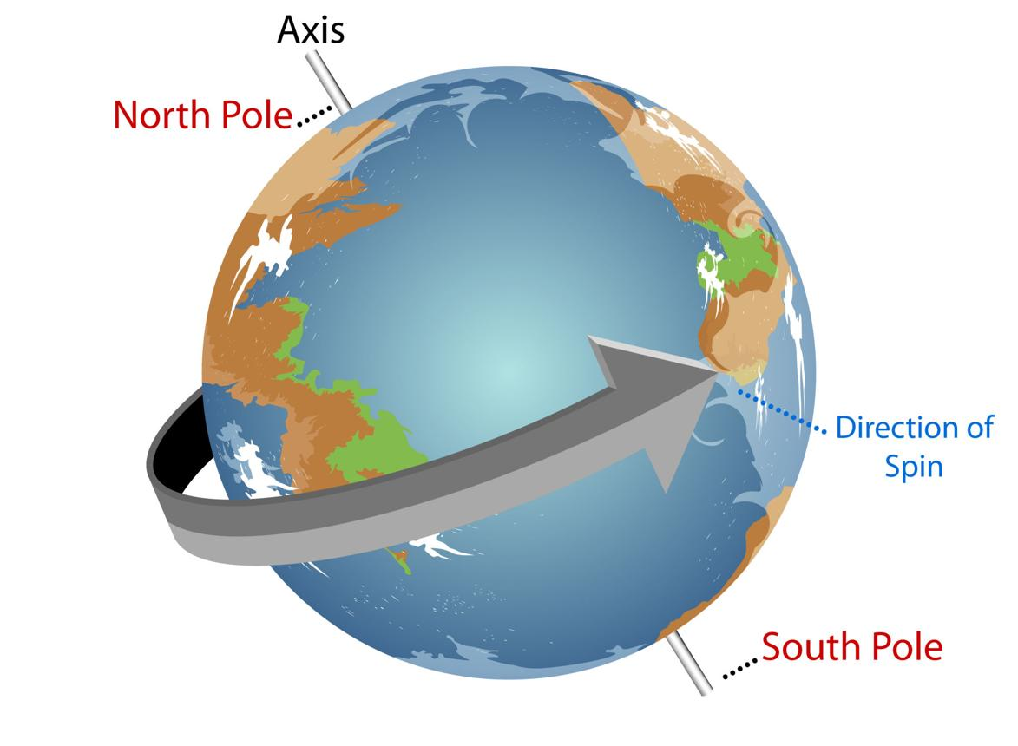

Equatorial Antipodal Points
# Source: AI Source: Provided by: [Data Path: Persons Table -> ID Column: 1, Name_En Column: Motasem Essam] -> From: [ChatGPT] on [7/25/2026]
Two points on the equator can be antipodal if they lie at opposite ends of an equatorial diameter. Their longitudes differ by ${180}^{∘}$.
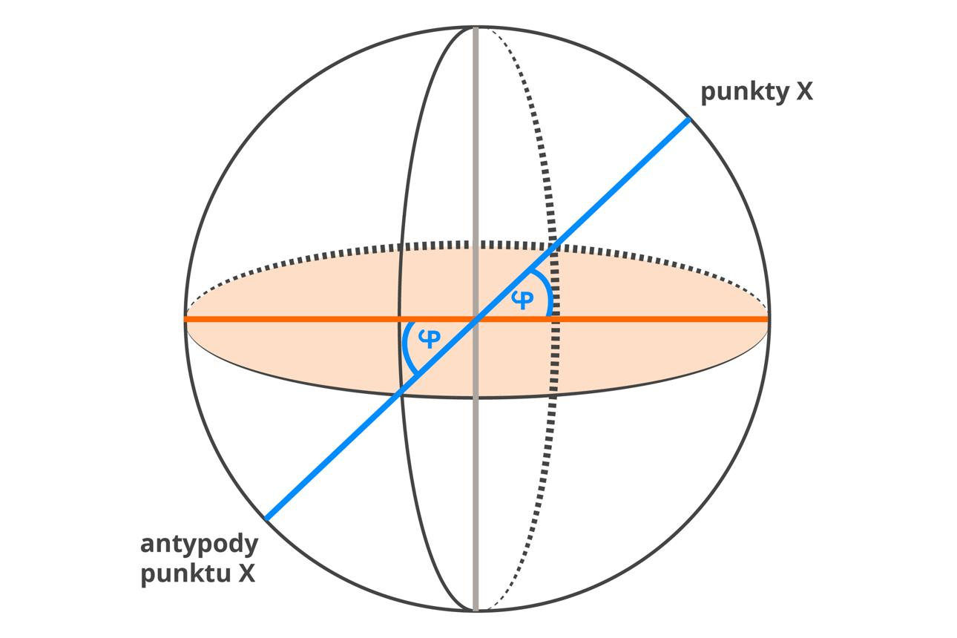

Worked Examples
# Source: AI Source: Provided by: [Data Path: Persons Table -> ID Column: 1, Name_En Column: Motasem Essam] -> From: [ChatGPT] on [7/25/2026]
Example 1 — Find the Distance Between Antipodal Points
Given: A sphere has a radius of $9\text{ cm}$.
Solution:
$$AB=2R=2\left(9\right)$$
$$\boxed{AB=18\text{ cm}}$$
Answer: The antipodal points are $18\text{ cm}$ apart in a straight line.
Example 2 — Find the Antipodal Point Using Coordinates
Given: A sphere is centered at the origin, and point $A$ has coordinates
$$A=\left(3,-4,5\right).$$
The antipodal point is obtained by reversing every coordinate's sign:
$$B=\left(-3,4,-5\right)$$
Answer: The antipodal point is $\boxed{\left(-3,4,-5\right)}$.
Example 3 — Antipodal Points on a Unit Sphere
Given: Point $A$ on a unit sphere has coordinates
$$A=\left(0,1,0\right).$$
Because the sphere has radius $1$, the antipodal point is:
$$B=\left(0,-1,0\right).$$
The straight-line distance between them is:
$$AB=\sqrt{{\left(0-0\right)}^{2}+{\left(-1-1\right)}^{2}+{\left(0-0\right)}^{2}}$$
$$\boxed{AB=2}$$
Example 4 — Antipodal Points on Earth's Surface
On an idealized spherical Earth, a point at latitude ${30}^{∘}$ North and longitude ${40}^{∘}$ East has its antipodal point at:
- Latitude: ${30}^{∘}$ South
- Longitude: ${140}^{∘}$ West
The latitude changes sign, and the longitude shifts by ${180}^{∘}$, with the result expressed in the conventional longitude range.

Antipodal Nature vs. Related Concepts
# Source: AI Source: Provided by: [Data Path: Persons Table -> ID Column: 1, Name_En Column: Motasem Essam] -> From: [ChatGPT] on [7/25/2026]
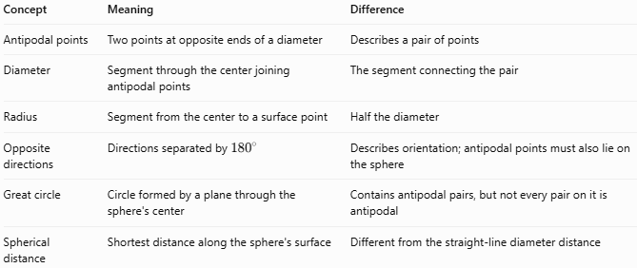
Concept | Meaning | Difference
Antipodal points | Two points at opposite ends of a diameter | Describes a pair of points
Diameter | Segment through the center joining antipodal points | The segment connecting the pair
Radius | Segment from the center to a surface point | Half the diameter
Opposite directions | Directions separated by ${180}^{∘}$ | Describes orientation; antipodal points must also lie on the sphere
Great circle | Circle formed by a plane through the sphere's center | Contains antipodal pairs, but not every pair on it is antipodal
Spherical distance | Shortest distance along the sphere's surface | Different from the straight-line diameter distance

Straight-Line Distance vs. Surface Distance
# Source: AI Source: Provided by: [Data Path: Persons Table -> ID Column: 1, Name_En Column: Motasem Essam] -> From: [ChatGPT] on [7/25/2026]
Antipodal points are separated by a straight-line distance equal to the diameter, but traveling along the sphere's surface requires a half-circumference along a great circle.
For a sphere of radius $R$:
Straight-line distance:
$$\boxed{d_{\text{straight}}=2R}$$
Shortest surface distance:
$$\boxed{d_{\text{surface}}=πR}$$
For example, if $R=10\text{ cm}$, the straight-line distance is $20\text{ cm}$, while the shortest surface distance is approximately $31.42\text{ cm}$.

Applications
# Source: AI Source: Provided by: [Data Path: Persons Table -> ID Column: 1, Name_En Column: Motasem Essam] -> From: [ChatGPT] on [7/25/2026]
- Geometry: Studying diameters, symmetry, and opposite points on a sphere.
- Geography: Finding approximate opposite locations on Earth.
- Astronomy: Describing opposite directions on a celestial sphere.
- Navigation: Understanding the relationship between locations separated by half a great-circle route.
- Mathematics: Working with vectors, spherical coordinates, and antipodal mappings.

Key Points
# Source: AI Source: Provided by: [Data Path: Persons Table -> ID Column: 1, Name_En Column: Motasem Essam] -> From: [ChatGPT] on [7/25/2026]
- Every point on a sphere has exactly one antipodal point.
- Antipodal points lie on the same diameter, on opposite sides of the center.
- The center is the midpoint of the segment joining them.
- The straight-line distance between them is $2R$.
- The shortest surface distance between them is $πR$.
- In coordinates centered at the sphere's center, the antipodal point is found by reversing all three coordinate signs.
- On Earth, antipodal locations have opposite latitudes and longitudes separated by ${180}^{∘}$.

Conclusion
# Source: AI Source: Provided by: [Data Path: Persons Table -> ID Column: 1, Name_En Column: Motasem Essam] -> From: [ChatGPT] on [7/25/2026]
The antipodal nature of a sphere describes the relationship between pairs of points located directly opposite each other across the sphere's center. This property connects sphere geometry with diameters, symmetry, vectors, and spherical navigation.

